

DESIGN AND CONSTRUCTION OF A MOBILE CONTROL ROBOT ARM ON A ROBOTIC WHEEL
BY
OKE IYANUOLUWA ENOCH
17BD005101/1701326

A PROJECT REPORT SUBMITTED TO

THE DEPARTMENT OF ELECTRICAL AND INFORMATION ENGINEERING
COLLEGE OF ENGINEERING
LANDMARK UNIVERSITY, OMU-ARAN, KWARA STATE, NIGERIA

IN PARTIAL FULFILLMENT OF THE REQUIREMENTS FOR THE AWARD OF BACHELOR OF ENGINEERING (B.ENG.) DEGREE IN ELECTRICAL AND INFORMATION ENGINEERING.
JULY 2022.

CERTIFICATION
The undersigned certifies that this project report, Titled ROBOTIC ARM ON ROBOTIC TANK WHEEL (ZETABOT) USING ESP 32 AND ARDUINO NANO was carried out by OKE IYANUOLUWA ENOCH, with Matriculation number 17BD005101 and meets the requirement of the Department of Electrical and Information Engineering (B.Eng.) degree in Electrical and Information Engineering.

__________________________ ___________________________
DR. P.K OLULOPE Date
(Supervisor)

_____________________________ _____________________________
DR. P.K OLULOPE Date
(Ag. Head of Department)

______________________________ _____________________________

(External Examiner) Date

DEDICATION
I dedicate this project work to the Almighty God, the source of my help and inspiration during this project, who has always been on my side throughout my academic journey at Landmark University. To my supervisor, Dr. P. K. Olulope without whose never-failing attitude to work, encouraging and scrutiny, this project would not have been as it is. I also dedicate this project to my family, the family of Mr Oke Babatunde who has been my source of everything throughout my academic career and also to my friends, and lecturers who were there for me and made an impact throughout this facet of my academic life.

ACKNOWLEDGEMENT
I would love to acknowledge the management of Landmark University for providing a conducive environment for learning and to carry out this project successfully.
I would also like to express my special thanks of gratitude to my supervisor Dr. P. K Olulope who gave me the golden opportunity to do this wonderful project on the Topic Robotic Arm on Robotic Tank Wheel Using Esp 32 And Arduino Nano, which also helped me in doing a lot of research and I came to know about so many new things. I am grateful.
Secondly, I would also like to thank my parents and friends, who helped me a lot in finalizing this project within the limited time frame.

SECTION | CONTENTS | PAGE
ii | CERTIFICATION | ii
iii | DEDICATION | iiI
iv | ACKNOWLEDGEMENT | iv
v | TABLE OF CONTENTS | v – vi
vii | TABLE OF FIGURES | vii
1 | CHAPTER 1: INTRODUCTION
1.1 | INTRODUCTION | 1
1.2 | BACKGROUND OF STUDY | 1
1.3 | AIM AND OBJECTIVES | 2
1.4 | SCOPE AND LIMITATIONS OF THE PROJECT | 2
1.5 | STATEMENT OF THE PROBLEM | 3
2 | CHAPTER 2: LITERATURE REVIEW
2.1 | HISTORY OF ROBOTICS | 4
2.2 | THE FIRST MODERN ROBOTS | 4
2.3 | MICROCONTROLLER | 5
2.3.1 | TERMINOLOGY | 5
2.3.2 | ESP 32 | 5
2.3.3 | ARDUINO NANO | 8
2.3.4 | POWER SUPPLY | 9
2.3.5 | SERIAL COMMUNICATION | 9
2.4 | MOTOR DRIVER | 9
2.5 | MOTOR | 12
2.6 | SERVO | 13
2.7 | 16 * 2 LCD SCREEN | 14
2.8 | ARDUINO IDE | 15
2.9 | KODULAR | 16
2.11 | 18650 15A 3S CHARGER MODULE | 17
2.12 | XL6019 DC TO DC BOOSTER MODULE | 17
2.13 | 5.5v 70ma SOLAR PANEL | 18
3 | CHAPTER 3: DESIGN AND METHODOLOGY
3.1 | RESEARCH METHODOLOGY | 19
3.2 | TOOLS | 20
3.2.1 | HARDWARE | 20
3.2.2 | SOFTWARE | 20
3.3 | SYSTEM DESIGN | 21
3.4 | CIRCUIT DESIGN | 22
3.5 | METHODOLOGY | 23
3.5.1 | SETTING UP THE ESP 32 CAM AND ARDUINO NANO ON ARDUINO IDE | 23
3.5.2 | BUILDING THE APP ON KODULAR | 23
3.5.4 | CONNECTING I2C LCD TO THE ARDUINO NANO | 24
3.5.5 | CONNECTING SERVO TO THE ARDUINO NANO | 24
3.5.6 | CONNECTING THE MOTOR CONNECTED TO MOTOR DRIVER TO ESP 32 CAM | 25
3.5.7 | PROGRAM CODE | 26
4 | CHAPTER 4
4.1 | RESULTS AND DISCUSSION | 43
5 | CHAPTER 5
5.1 | RECOMMENDATION | 44
5.2 | CONCLUSION | 44
 | REFERENCES | 45

Fig 2.3.2 | LAYOUT OF ESP 32 CAM | 8
Fig 2.3.3 | LAYOUT OF ARDUINO NANO | 8
Fig 2.4.1 | SCHEMATIC DIAGRAM FOR MOTOR DRIVE MODULE | 11
Fig 2.4.2 | LAYOUT OF L298N MODULE | 11
Fig 2.5 | DIAGRAM OF 12V330 GEARED MOTOR | 13
Fig 2.6.1 | SCHEMATIC DIAGRAM FOR MG996R SERVO MOTOR | 13
Fig 2.6.2 | LAYOUT OF MG996R SERVO MOTOR | 14
Fig 2.7 | LAYOUT OF 16 X 2 LCD | 14
Fig 2.8 | ARDUINO IDE | 15
Fig 2.9 | LAYOUT OF KODULAR | 16
Fig 2.10 | LAYOUT OF 18650 15A 3S CHARGER MODULE | 17
Fig 2.11 | LAYOUT OF XL6019 DC TO DC BOOSTER MODULE | 18
Fig 2.12 | LAYOUT OF 5.5V 70MA SOLAR PANEL | 18
Fig 3.1 | FLOW CHART OF RESEARCH METHODS | 19
Fig 3.3.1 | BLOCK DIAGRAM | 21
Fig 3.3.2 | PICTORIAL CIRCUIT DIAGRAM | 22
Fig 3.4 | CIRCUIT DIAGRAM | 22
Fig 3.5.4 | CONNECTING THE I2C LCD TO THE ARDUINO NANO | 24
Fig 3.5.5 | CONNECTING SERVO TO THE ARDUINO NANO | 25
Fig 3.5.6 | PICTORIAL CIRCUIT DIAGRAM OF CONNECTING THE MOTOR CONNECTED TO MOTOR DRIVER TO ESP 32 CAM | 26
Fig 4.1 | FINAL CONSTRUCTED PROJECT RESULT | 43
TABLE OF FIGURES

CHAPTER 1
1.1 INTRODUCTION
It is true that in recent years, the power, functionality, and ubiquity of computers and the Internet have outpaced earlier projections for the rate of technological innovation and utility in everyday life. Experts anticipate that the world will soon be flooded with sophisticated computer chips, which will progressively find their way into our products, houses, clothes, and even our bodies.
A nearly similar goal, on the other hand, has remained elusive. Unlike the widely unanticipated main streaming of computers, the robotics team failed to live up to the 1950s predictions. Experts were astounded by the possibilities at this point. The computer's seemingly magical computation believes that precisely the proper software is written down. Computers have the potential to become the artificial brains of advanced autonomous robots. They believe that such robots will mop floors, mow lawns, and generally eradicate chores from our life in a decade or two.
That did not appear to be the case. Industrial robots have had a significant impact on the automobile sector, as well as other industries. However, this level of automation falls far short of what many scientists and engineers had hoped for in terms of versatility, portability, and automation. Thousands of researchers have become frustrated in their pursuit of these robots, and hundreds of firms have gone bankrupt. It's not that the mechanical "body" is unreachable; industrial robots demonstrate that articulated arms and other mobile systems appropriate for manual tasks already exist. Instead, the computerized pairing brain has not yet advanced to the level of sophistication required to construct a human-like robot.

1.2 BACKGROUND OF STUDY
In a variety of fields, robots are gaining traction. Almost every day, we read in the press about robots in nursing homes giving the old company or cars that can park or even drive themselves without human supervision. It appears that the world is becoming increasingly automated when we call a corporation and are connected to a computer. And the robots are getting smarter; scientists are working on making more friendly robots that can read facial expressions and have conversations.
The progression appears to go from limited industrial robots to increasingly autonomous machines and systems, with singularity machines outsmarting humans in science fiction films like Terminator or I-Robot at the extreme, more speculative end of the spectrum.
In this thesis, the word "autonomous system" is used to refer to several phrases such as "robot," "artificial agent," and "unmanned aerial vehicle." The autonomy, not necessarily the embodiment commonly associated with robots, is the relevant feature for the philosophical concerns in the thesis. It's just as important to have an autonomous system integrated in something that isn't a robot. However, as it is in the literature, the term robot is most usually used.
Although roboticists do not appear to agree on how to interpret the term robot, autonomy or independence appears to be a common denominator. A computer attached to a printer, for example, would be a robot if it were defined as "a computer with sensors and actuators that allow it to interact with the external world." Something more, some amount of "thinking" or "doing," is required to distinguish it from automata such as thermostats or computers attached to printers.

1.3 AIM AND OBJECTIVES
1.3.1 AIM:
To develop a low-cost research robot used in any area of field.

1.3.2 OBJECTIVES:
Objective of this project are as follows:
- To design an inexpensive system that is user-friendly and easy to use.
- To construct a mobile app control robot for research purpose.
- To develop an internet base control system that enables transfer and receiving data through the internet.
- To interface the system with an internet android application enabling cloud data communication.

1.4 SCOPE AND LIMITATIONS OF THE PROJECT
The project scope, which is in line with its aim to use an affordable agrotechnology robot, targets for field research that is controlled via a mobile app. Esp 32 Cam and Arduino Nano are the main microcontrollers used for the system as communication to a cloud store through the internet between the cloud store and the mobile app.
The project will not be limited to just field research purposes only. A Kodular Mobile Application, Bluetooth serves as the intermediate between the user sending instructions through Bluetooth connection.

1.5 STATEMENT OF THE PROBLEM
Despite robot researchers' efforts and research, the goal of emulating human intelligence and appearance has yet to be reached. The majority of robots are not adaptable, and they do not recognize objects effectively. Prioritizing the inefficiencies connected with robotics technology is critical for its successful and proper operation. Though widespread usage of robotics technology will eliminate many human jobs, it will result in increased unemployment in the society. Because the use of robots to do diverse tasks will result in the loss of human jobs, the implementation should be done systematically. Robotic advancements will reduce the number of high-end precision tasks and will benefit a variety of industries, including agriculture, military, and health care. As a result, robots will be used as workplace assistants with a degree of balance between genuine requirements and greed. Many jobs that are beyond human capability can be accomplished with the aid of robotics, which will be quite beneficial in its functioning. The growth of robot technology will be incredible, and robots can now be found in almost every field, from transportation to health, recreation to industry.
CHAPTER 2
LITERATURE REVIEW
2.1 History of Robots
One of the first examples of a mechanical device designed to do a particular physical task on a regular basis may be found in Egyptian water clocks from around 3000 B.C. These clocks used human figures to strike the hour bells. The pulley and screw were constructed by Archytus of Taremtum, who also invented a flying wooden pigeon in 400 B.C. Hydraulically powered statues that could speak, gesture, and prophesy were common in Hellenistic Egypt during the second century B.C.
A doll that resembles a human was made in the first century AD by Petronius Arbiter. Giovanni Torriani created a wooden robot that could deliver the Emperor's daily bread in 1557. Before the twentieth century, the number of inventive but unusable automata (i.e., robots) reached its height in the 1700s. The nineteenth century saw the development of numerous new robotic creations, such as Thomas Edison's talking doll and a steam-powered robot created by Canadians. The modern robot was made possible by scientific developments in the field of robotics made in the 20th century, despite the fact that previous historical advances may have planted the seeds of inspiration for it. The modern robot may have been inspired by these historical findings, but scientific advancement in the field of robotics in the 20th century far exceeds earlier successes.

2.2 The First Modern Robots
Early in the 1950s, a man from Louisville, Kentucky named George C. Devol created the first robots as we know them today. The "Unimate," or "Universal Automation," reprogrammable manipulator was created by him, and it was granted a patent. For the following ten years, he made failed attempts to market his products in the sector. Businessman and engineer Joseph Engleberger purchased Devol's robot patent in the late 1960s and turned it into an industrial robot. He then founded Unimation to produce and sell the robots. Because of his contributions, Engleberger is known in the industry as "the Father of Robotics." New robot development has advanced significantly in academia as well. In 1958, Charles Rosen oversaw a research group at Stanford Research Institute that created "Shakey," a considerably more advanced robot than the Unimate that had been created initially for specialized industrial applications. Shakey was able to walk around the space, see the action through his television "eyes," travel across uncharted territory, and to some extent react to his environment. He was given the name because of his clumsy and clattering actions.

2.3 MICROCONTROLLER
2.3.1 TERMINOLOGY
A microcontroller is a single-chip microcomputer made with VLSI technology. Microcontrollers are frequently referred to as embedded controllers. Microcontrollers with varied word lengths, such as 4bit, 8bit, 64bit, and 128bit microcontrollers, are now available on the market. Microcontrollers are compact microcomputers used to control the functions of embedded systems in office equipment, robotics, home appliances, automobiles, and other devices. Memory, peripherals, and, most crucially, a CPU are all included in a microcontroller.
Microcontrollers are primarily used in gadgets that require the user to exercise some level of control.

2.3.2 ESP 32 CAM
This project also made use of Esp 32 Cam. With the ESP32-S chip, the ESP32-CAM is a very compact camera module. The camera on the module is an OV2640. Additional GPIOs are available for connecting devices. The controller is built on a 32-bit CPU that operates at a maximum frequency of 240MHz. It contains an external 4M PSRAM in addition to its internal 520 KB SRAM. It has a SoC module that combines 802.11b/g/n Wi-Fi and Bluetooth/BLE. It supports embedded Lwip, FreeRTOS, and image Wifi upload. There is a PSRAM Chip with an onboard voltage regulator IC. The board is breadboard friendly and contains a single reset button. On the board, there is an LED that can be utilized as a signal.
This module comes with an antenna built in, and if an extra antenna with more power and range is required, it may be connected to the IPEX connector. You must attach a jumper or a zero-ohm resistor on the PCB next to the antenna in order to utilize it.

ESP32-CAM Specifications
Since the ESP32-CAM is based on the ESP32-S module, it has similar features. It has these characteristics:
- 802.11b/g/n Wi-Fi
- Bluetooth 4.2 with BLE
- UART, SPI, I2C and PWM interfaces
- Clock speed up to 160 MHz
- Computing power up to 600 DMIPS
- 520 KB SRAM plus 4 MB PSRAM
- Supports Wifi Image Upload
- Multiple Sleep modes
- Firmware Over the Air (FOTA) upgrades are possible
- 9 GPIO ports
- Built-in Flash LED

OV2460 Camera
The Camera Module is the most crucial component of the ESP32 CAM. The OV2640 Camera Module, which includes a 24 Pin Camera Holder, is the available Camera Module. It features a camera resolution that is the highest, at 1600 1200.
There is a connecting strip with gold plating. The camera and ESP32 are connected using this connector.

SD Card Support
An SD Card Holder that can accommodate cards up to 16GB is located on the back. When creating projects that rely on photographs, the SD card is utilized to store the images. Simply placing the SD Card into the SD Card Adapter establishes the connection.

Camera Specifications
On the back, there is an SD Card Holder that can hold cards up to 16GB. The SD card is used to store the images when developing projects that rely on photos. The connection is made simply by inserting the SD Card into the SD Card Adapter
- 2 Megapixel sensor
- Array size UXGA 1622×1200
- Output formats include YUV422, YUV420, RGB565, RGB555 and 8-bit compressed data
- Image transfer rate of 15 to 60 fps

ESP32 CAM GPIO Pins
Numerous GPIO pins, including UART, SPI, I2C, PWM, ADC, and DAC, are supported. This module provides both a 5V pin and a 3.3V VCC pin. Additionally, there are several GND Pins.
The following pins are internally connected to the microSD card reader:
GPIO 14: CLK
GPIO 15: CMD
GPIO 2: Data 0
GPIO 4: Data 1 (also connected to the on-board LED)
GPIO 12: Data 2
GPIO 13: Data 3

ESP32-CAM FTDI Connection
For the purpose of programming the board, a USB-to-TTL Converter Module or an FTDI Module must be used; there are numerous FTDI Module options based on the CP2102 or CP2104 chip, among others.
Make the connection between the FTDI module and the ESP32 CAM module as shown below to get started with the module.
Connect the ESP32's 5V and GND pins to the FTDI module's 5V and GND pins. Rx and Tx should be similarly connected to UOT and UOR Pin. The IO0 and GND Pins must be connected via a short circuit, which is the most crucial step. In order to program the device, do this. After programming is complete, the IO0 and GND must be removed. The Esp 32 Cam can be programmed using the Arduino IDE software and is compatible with LUA, Java, C, and C++. The design of Esp 32 Cam is seen in the figure.

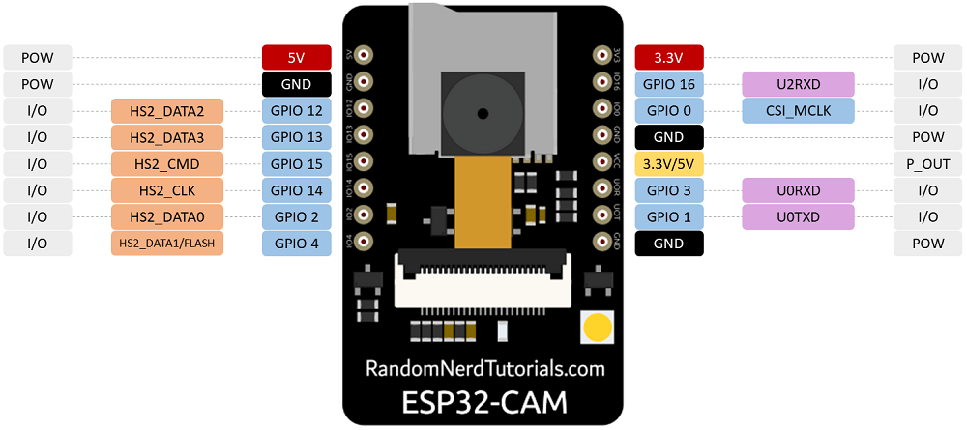

Fig 2.3.2: Layout of Esp 32 Cam

2.3.3 ARDUINO NANO
For this project, an Arduino Nano board was also utilized. It is an ATmega328-based, surface-mount embedded version of Arduino that is compact, complete, and compatible with breadboards. Electrically speaking, it is identical to the Arduino Diecimila save for having more analog input pins and a built-in +5V AREF jumper. The Nano 3.0 connects to a computer using a Mini-B USB cable and can be powered by a 5V regulated external power supply, a 6-20V unregulated external power supply, or the Mini-B USB connection (pin 30). (pin 27). The greatest voltage source is automatically chosen as the power supply. The Nano features more breadboard space for users thanks to its smaller size than either the Arduino Uno or Micro, which both have breadboard functionality. Additionally, it has a pin arrangement that complements the Mini or the Basic Stamp (TX, RX, ATN, GND on one side, power, and ground on the other).
The Arduino Nano may be programmed using the Arduino IDE software, and it supports the programming languages LUA, Java, C, and C++. The Arduino Nano's layout is seen in the figure.
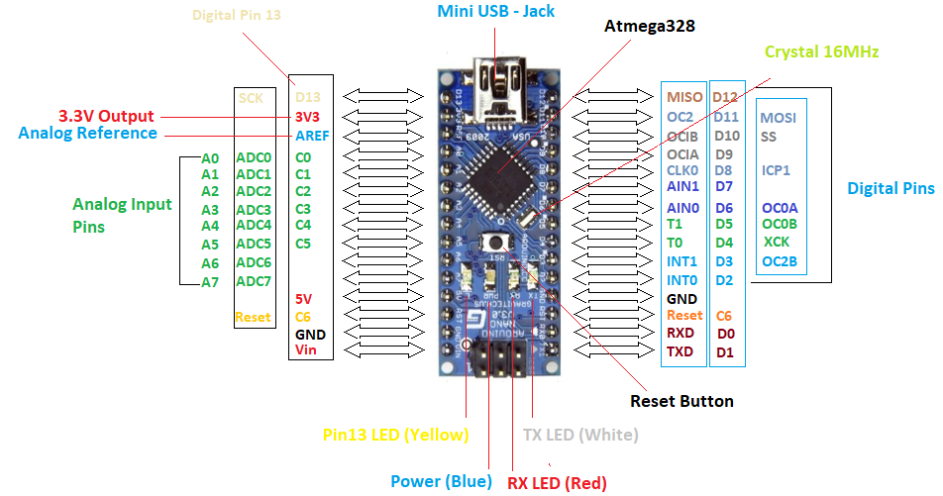

Fig 2.3.3: Layout of Arduino Nano
2.3.4 POWER SUPPLY
Esp 32 Cam Power Supply
The Esp 32 Cam can be power by two methods which are through the onboard VIN pin through which a regulated 5v voltage source is connected to and also through FTDI Module to a computer system. The Esp 32 cam can be activated with voltages ranging from 3.3v to 5v. The Esp 32 Cam has an AMS1117 voltage regulator that creates the required voltage for the Esp. The AMS1117 has an absolute maximum input voltage of 15V. It has a dropout voltage of 1.1v -1.3v. The onboard 5v and 3.3v pin can supply power to connected devices.

Arduino Nano Power Supply
The Arduino Nano can be power by two methods which is through the on-board Mini-B USB connector to a computer system and the onboard VIN pin through which a regulated 5v. The Arduino Nano has an LM1117IMPX-5.0 voltage regulator that supplies 5v to the Arduino Nano. The LM1117IMPX-5.0 has an absolute maximum input of 20v. The LM1117IMPX-5.0 supports input voltages between 7V and 12V with a maximum current of 900mA. The onboard 5v and 3.3v pin can supply power to connected devices.

2.3.5 SERIAL COMMUNICATION
Serial communication is used for communication between the Arduino boards and a computer or other devices. All Arduino boards have at least one serial port (also known as a UART or USART). It communicates on digital pins 0 (RX) and 1 (TX) as well as with the computer via USB.

2.4 MOTOR DRIVER
An integrated circuit chip called a motor driver IC is used to control motors in embedded and autonomous robotic systems. The L293D and ULN2003 are the most often utilized motor driver ICs in small robots and remote-controlled autos. Undoubtedly, a motor driver is something that makes a motor move in response to directions or inputs (high and low). It uses the low voltage provided by the controller or processor to drive a genuine motor, which needs a high input voltage. The motor driver IC controls the direction of the motor in accordance with the directives or instructions it gets from the controller.

The L298N Motor Driver Module
A monolithic circuit is built into the 15-lead Multiwatt and PowerSO20 packaging known as the L298N. It is a twin full-bridge high-voltage, high-current driver capable of driving inductive loads such as relays, solenoids, DC motors, and stepping motors. Two independent of input signal enable inputs can be used to enable or disable the device. An external sensing resistor can be connected to the corresponding external terminal once the bottom transistor emitters of each bridge have been connected together. An additional supply input is included to enable the logic to function at a lower voltage.

Specification
- Driver: L298N
- Driver power supply: +5V~+46V
- Driver Io: 2A
- Logic power output Vcc: +5~+7V (internal supply +5V)
- Logic current: 0~36mA
- Controlling level: Low -0.3V~1.5V, high: 2.3V~Vss
- Enable signal level: Low -0.3V~1.5V, high: 2.3V~Vss
- Max power: 25W (Temperature 75 Celsius)
- Working temperature: -25C~+130C
- Dimension: 60mm*54mm
- Driver weight: ~48g
- Other extensions: current probe, controlling direction indicator, pull-up resistor switch, logic part power supply.

Hardware Diagram
- CSA: The current test pin for motor A, this pin can be wired to a resistor for current testing or tied to a jumper to disable it.
- CSB: The current test pin for motor B, this pin can be wired to a resistor for current testing or tied to a jumper to disable it.
- VMS: VMS is the 5V-35V power source for the motor. VMS is positive, GND is negative.
- 5V: Power input for the logic circuit on the board.
- 5V-EN: 5V source jumper. When the jumper is put on, The 78M05 supplies the 5V power for the logic circuit on the board from the VMS port (7V < VMS < 18V). The power of the logic circuit of the board is supplied by the 5V port when this jumper is put off.
- U1/2/3/4: Pull up resistor for IN1/2/3/4. Putting on the jumper enable the pull-up resistor for the microcontroller, putting off it disable it.
- EA/EB: EA/EB is to enable pin for the two motors A/B, the motor speed also can be controlled by the PWM of this pin.
- IN1/2/3/4: IN1/2/3/4 is the pin for the motor control. Motor B is the same as Motor A.
Its schematic diagram and Layout is as shown in figure (a) and (b):
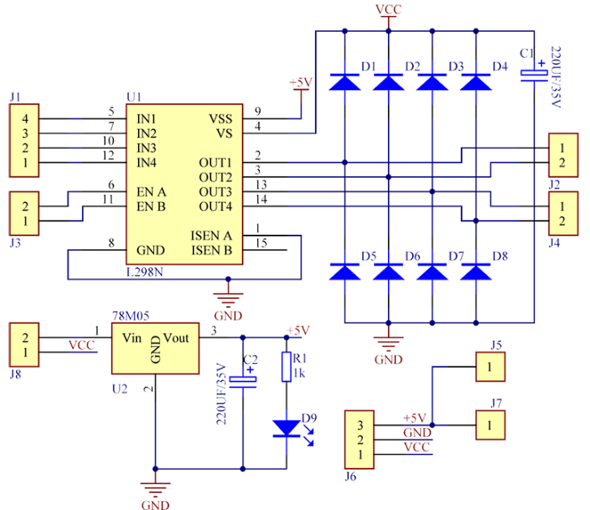

(a) Fig 2.4.1: Schematic diagram for motor drive module

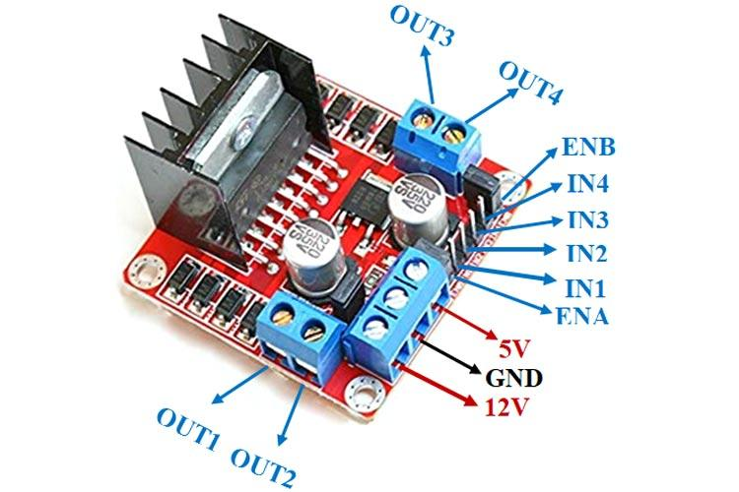

(b) Fig 2.4.2: Layout of L298N Module

2.5 MOTOR
A DC motor is any of a class of rotary electrical motors that converts direct electrical current energy into mechanical energy. DC motor work on the current and voltage needed for the capabilities of microcontroller but DC moto is necessary to use some external device of electronic to drive the and control the motor, and it required individual power supply. There are many ways to drive the DC motor from the output of the device. However, transistors also use full to drive the DC motor and the other way to control the direction of the motor is L298N drive it is an integrated circuit.

How DC motor work
Stator, rotor, and armature are the three primary components of a DC motor. The revolving component known as the armature simple coil and a magnetic field are both present in the stator, which is permanently managed. Here, the armature is connected to the DC power source, and a two-piece ring that is attached within the motor shaft is known as the "commutator ring." A magnetic field was created by applying DC to the commutator, where flow travels through the coil.

Specification
- Model: 112V330 to DC gear motor
- Rated Voltage: DC12V
- Original Speed: 1200rpm
- No-load Speed: 330rpm/0.24A
- Maximum Efficiency Point: Load 4kg.cm/235rpm/2.5W/0.58A
- Maximum Power Point: Load 7kg.cm/215rpm/3.1W/0.65A
- Maximum locked rotor force: 13kg.cm
- Blocking Current: 4.8A
- Shaft Extension Size: 14.5mm
- Motor Shaft Diameter: 4mm D3.5

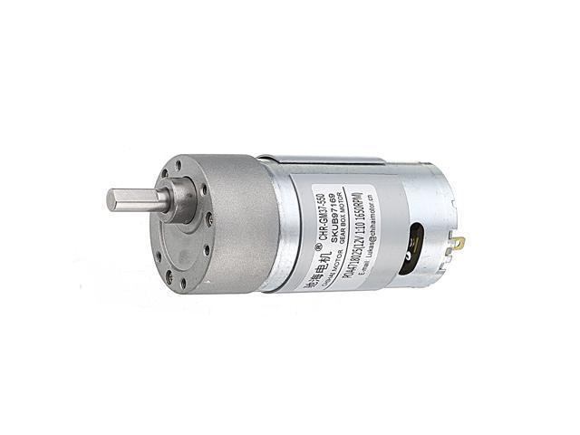

Fig 2.5: Diagram of 12v330 Geared Motor

2.6 SERVO
A servo motor is a rotary actuator or motor that enables exact angular position, acceleration, and velocity control. It possesses characteristics that a standard motor lacks. Standard servos are used to maintain a specific angle and use closed-loop feedback control. They are not intended for a full rotation. Servos are utilized in applications that require a lot of torque and precise rotation within a certain range of angles. The MG996R Servo Motor is a servo motor that uses PWM control signals to function. Based on the width of the pulse fed in by a signal input, the servo maintains a specific angle (position).

Specifications
- Weight: 61 g
- Dimension: 54 x 38 x 20 mm approx.
- Gear Type: All Metal Gears
- Stall torque:12kg/cm(6V)
- Power Supply: Through External Adapter
- Operation Voltage: 4.8 - 7.2 V
- Temperature range: 0'C to 55‘C
- Operating Speed: 0.17sec / 60 degrees (4.8V no load)
- Operating Speed: 0.13sec / 60 degrees (6.0V no load)
- Pin configuration: Yellow / Light Orange / White (Signal), Red / Dark Orange (+5V), Brown/Black (Ground)

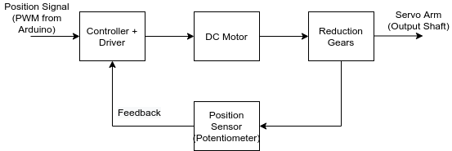

(a) Fig 2.6.1: Schematic diagram for MG996R Servo Motor

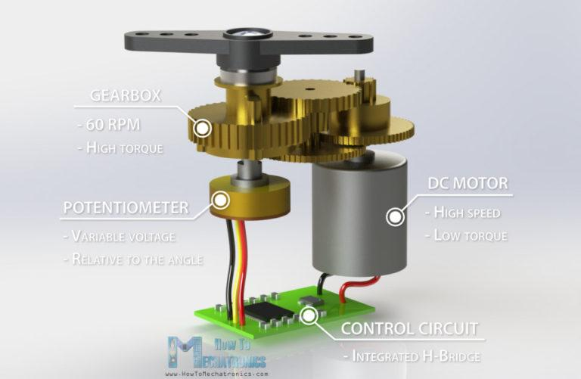
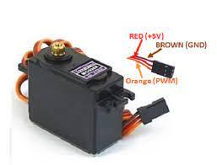

(b) Fig 2.6.2: Layout of MG996R Servo Motor

2.7 16 x 2 LCD SCREEN
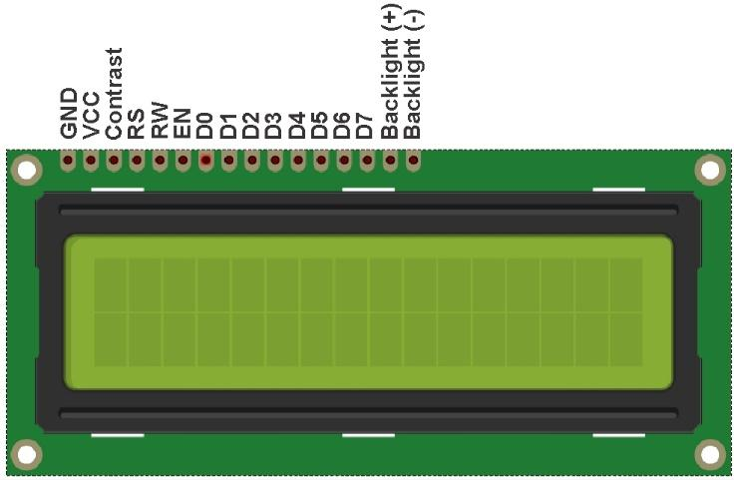
Liquid Crystal Display is an electronic module for displaying letters, numbers and characters. A 16 x 2 LCD means the screen can display 16 characters in two (2) lines. The LCD is used to display messages sent from Arduino Nano.

Fig 2.7: Layout of 16 x 2 LCD

2.8 ARDUINO IDE
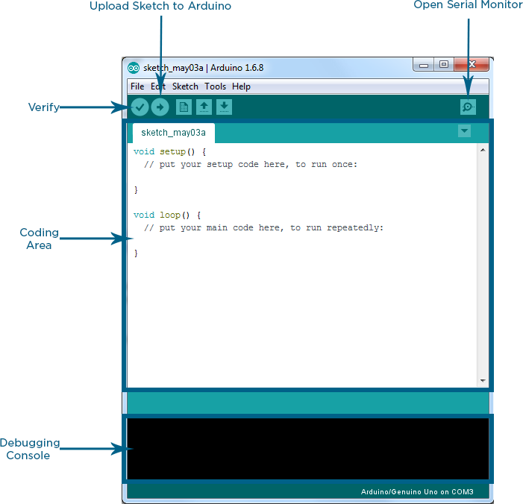
The Arduino IDE (Integrated Development Environment) is software that is used to write and upload codes to the Esp 32 Cam and Arduino Nano, after which it must have been installed on a computer system that may have a Linux, Windows or Mac OS X operating system. This software makes use of gcc, G++ compiler and accepts programs in C and C++. Appropriate settings must be done before coding on the software.

Fig 2.8: Arduino IDE
2.9 KODULAR
Kodular is an online suite that largely consists of an online web application that allows users to create apps without having to know how to code. Kodular Creator is an MIT App Inventor distribution, which means it's based on the App Inventor open source project, though it's a lot better. Kodular Creator, on the other hand, is not an open-source project, and the source code is hosted privately on GitHub, however, there are additional repositories related to the Suite. The most visible difference between this App Inventor package and the App Inventor open source project is that it has more components, more granular control over the app, and capabilities not found in the open-source version. The package also includes an online app store to compete with the Google Play Store, as well as an extensions IDE for advanced users to create additional Kodular Creator components. Kodular Account, a mechanism for controlling all of these services from a single location, is available to provide control over all of them.

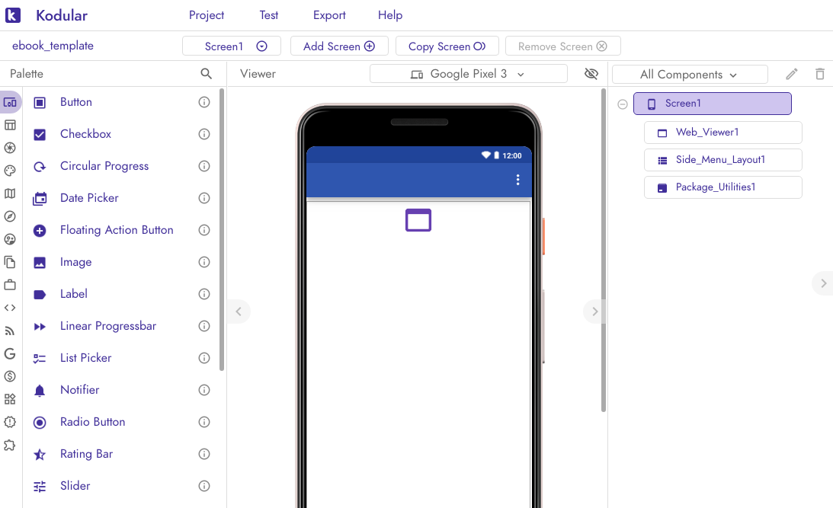

Fig 2.9 Layout of Kodular

2.10 18650 15A 3S CHARGER MODULE
This module is made for charging rechargeable lithium batteries using the constant-current/constant-voltage (CC/CV) charging method. In addition to safely charging a lithium battery the module also provides necessary protection required by lithium batteries.
The module specification
Model : HX-3S-FL25A-A
Charging voltage range: 12V
Over-discharge recovery voltage: 2.5v±0.05v,
Over-Discharge-Delay-Time: 144ms
Maximum Working Current: 10A
Maximum Peak current: 20A

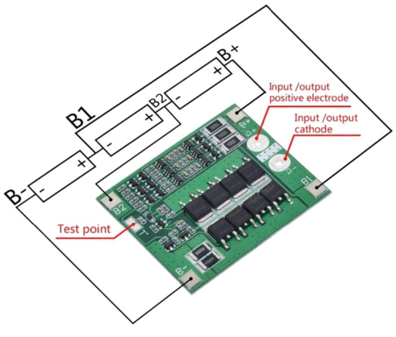

Fig 2.10: Layout Of 18650 15A 3s Charger Module

2.11 XL6019 DC TO DC BOOSTER MODULE
XL6019 DC-DC boost power supply module adjustable output regulator performance ultra LM2577 Model Specifications: XL6019 boost module Module Properties: non-isolated step-up Rectification: Non-Synchronous Rectification Input range: Limits: 3-40V, recommended values: 3V-35V Output Range: Limits: 5-45V, recommended values: 5V-40V (via rotary potentiometer) Input Current: Limits: 0-5A, recommended values: 0-3A Conversion efficiency: up to 94% Open frequency: 220KHz, the second generation of switching power supply technology Output ripple: less than 100mV Load regulation: &plusmn; 0.5% Voltage regulation: & plusmn; 0.5% Working temperature: Limits: -40 to +150 degrees Celsius, the recommended values: -20 to +85 degrees Celsius Reverse polarity protection: protection against reverse input 40V Size: 50MM 28MM 13MM With back protection, import TDK inductor, with a connecting column, the output 5V/12V/24V can be adjusted, performance beyond LM2577. Using conventional topology BOOST as a constant voltage output, the internal integration of MOSFET, peripheral devices, low system cost, built-in over temperature protection, over current protection of the full set of reliability protection circuit, high reliability. 1, the use of conventional topology BOOST complete set of constant voltage output, the internal integration of MOSFET, peripheral devices less, the system cost is low; 2, wide voltage range input, the input voltage up to 35V; 3, the output voltage can be adjusted, the highest can support 40V; 4, built-in over temperature protection, over current protection of the full set of reliability protection circuit, high reliability; 5, system conversion efficiency can reach more than 90%, easy to heat design; 6, TO263-5L standard package, suitable for 30W within the boost application.

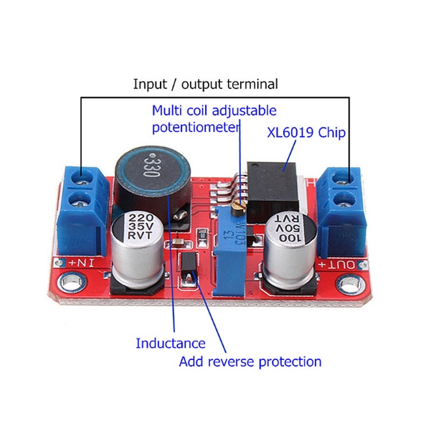

Fig 2.11: Layout Of Xl6019 Dc To Dc Booster Module

2.12 5.5v 70ma SOLAR PANEL
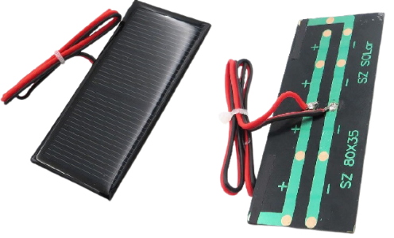
5.5v 70ma Solar Panel is a device used to absorb the sun's rays and convert them into a 5.5v 70ma power source.

Fig 2.12: Layout of 5.5v 70ma Solar Panel
Chapter 3
DESIGN AND METHODOLOGY
3.1 Research Methodology
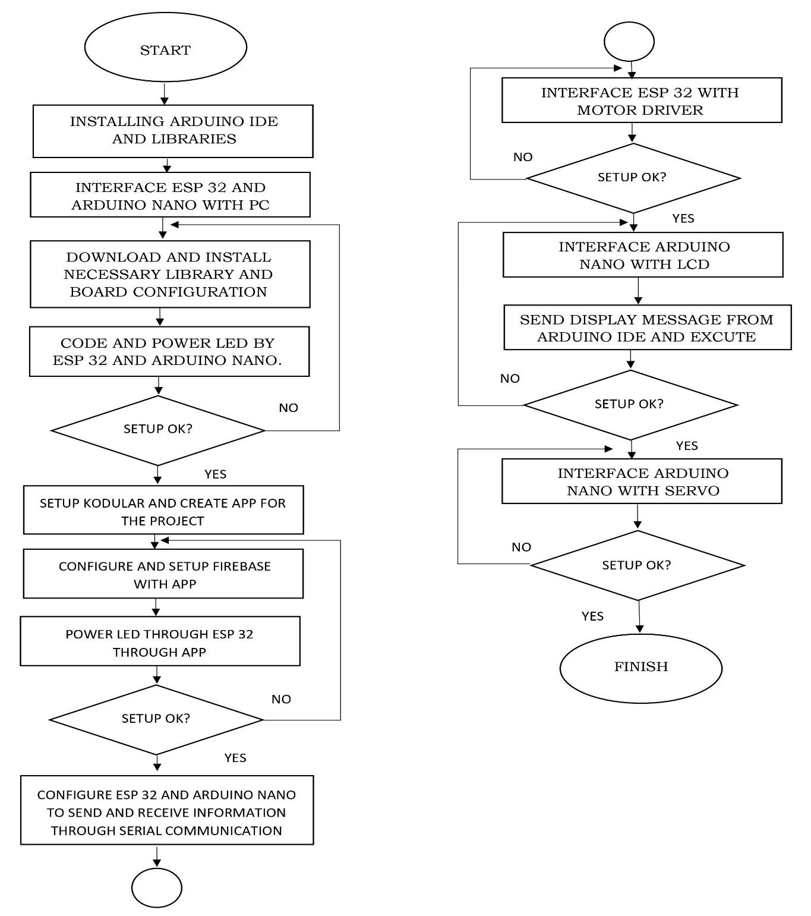
Fig 3.1 below is a flow chart diagram which explains the methods applied to achieve this project work.

Fig 3.1: Flow Chart of Research Methods
This project topic was selected based on studying the present Agricultural Research Technology Systems in Nigeria, before recommending a more practical approach. The circuit design for the system was laid, required hardware needed for the project were listed and ordered.
Hard connection and programming were successfully done after being conversant with the Arduino Ide and its language. After the setup was done and tested okay. I connected Esp 32 Cam, Arduino Nano, Bluetooth configuration with the app. Once the system is set up, it would be a replica of the block diagram and circuit diagram below:

3.2 TOOLS
This section involves the hardware and software materials that were used during this project.

    - Hardware
- Esp 32 Cam
- Arduino Nano
- 16 x 2 i2c LED
- Vero Board
- L298N Motor Driver
- Connecting wires
- 18650 Lithium Battery Case
- 18650 Lithium Battery
- Servo: Mg996r Servo and Mg995 Servo
- 12v330 Geared Motor
- Battery Indicator Module
- Switch
- Mobile Device

  - SOFTWARE:
- ARDUINO IDE
- KODULAR
- WEB BROWSER

  - SYSTEM DESIGN (BLOCK DIAGRAM)
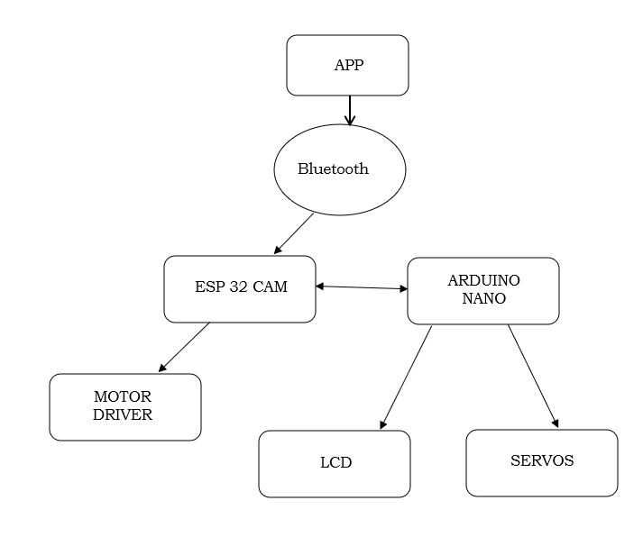

Fig 3.3.1: Block Diagram

The total voltage supplied to the system is 11v which is divided into 5v which is required to power both the Esp 32 Cam and Arduino Nano and 5 – 7v which is required to power the Servo and 6 -11v which is required to power the Motor.
The App will send and receive information through the Bluetooth, The Esp 32 cam will receive commands (instructions) from Bluetooth transmitter and send some information meant for the Arduino Nano, Arduino Nano controls the LCD and Servo while the Esp 32 Cam controls the Motor Driver.
Below is the pictorial circuit diagram:

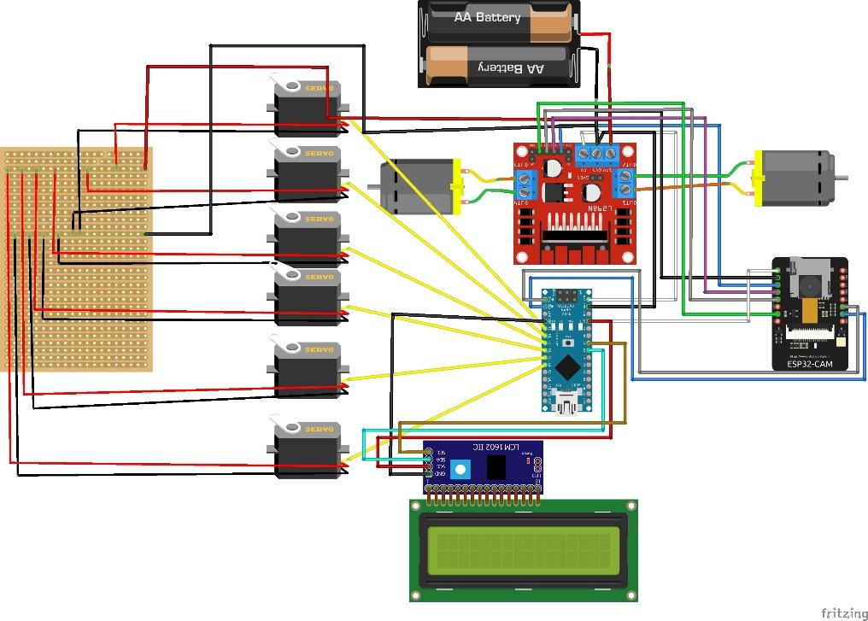

Fig 3.3.2: Pictorial Circuit Diagram

3.4 CIRCUIT DIAGRAM DESIGN:
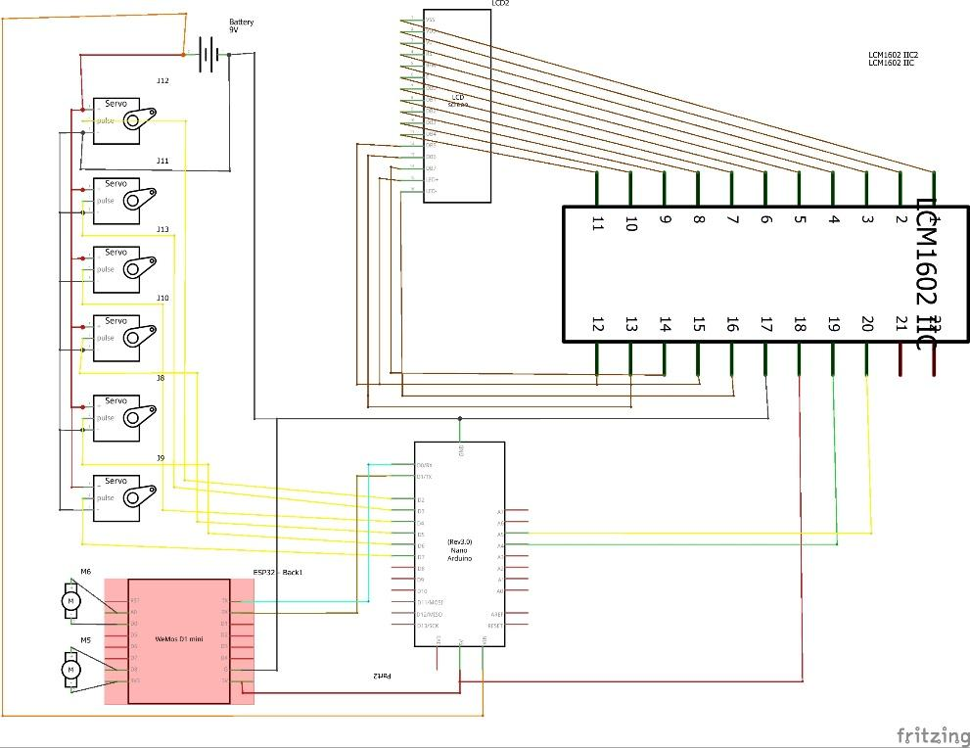

Fig 3.4: Circuit Diagram

3.5 METHODOLOGY:
3.5.1: SETTING UP THE ESP 32 CAM AND ARDUINO NANO ON ARDUINO IDE
When Arduino Nano is connected to the system and Esp 32 Cam is connected via FTDI Module, if the PC cannot recognize it, you have to download and install proper drivers for the devices. After plug in your boards, download Arduino IDE and run. On the IDE interface, go to the file and then in the preferences and put this link in https://raw.githubusercontent.com/espressif/arduino-esp32/gh-pages/packages_esp32_index.json and then to install the Esp 32 board into the Arduino Ide navigate to the tools, then navigate to board, click on board manager, then search for Esp 32 cam, select the latest version for the board and install, then navigate to sketch under include library navigate manage libraries and search for Esp 32, locate the Esp 32 library and install, if the Esp 32 library isn’t in the search list, Open web browser and search for Esp 32 library and download, navigate to sketch, under include library click on Add .zip library to install the downloaded library. After installing the board and library, under tools, navigate to board and select your desired board which might be AI Thinker Esp32-Cam or Arduino Nano. Make sure your port number is the same as where your board is connected, reflect on the port section under tools of the Arduino Ide. Other libraries needed for the project must be downloaded. Restart the pc and you are set to program.

3.5.2: BUILDING THE APP ON KODULAR
Open a web browser and type kodular.io on the search bar, Go to the Kodular Creator page. A Login screen will be displayed to you. Continue by logging in.
After that, you'll be directed to the Projects page. To start a new project, click the New Project button. You are free to use whatever name you choose.
Next should be selected. The project will be created, and you will be directed to your project's Designer page. For testing your app while it's being developed, download Kodular App Companion on your mobile phone and connect the companion to kodular for better testing of the app.

3.5.4: CONNECTING THE I2C LCD TO THE ARDUINO NANO
A 16 x 2 LCD screen was also used in the project. The Gnd and Vcc pin on the I2c were connected to the Gnd and 5v pin of the Arduino Nano respectively and SDA and SCL of the I2c were connected to A4 and A5 pins of the Arduino Nano respectively as shown in the picture below:

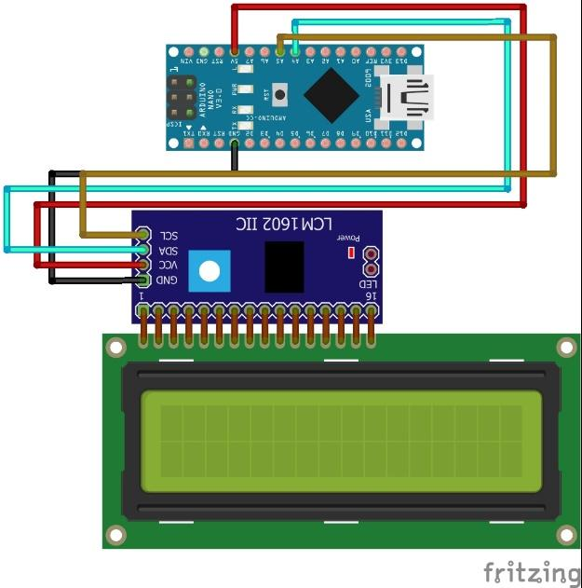

Fig 3.5.4 Connecting The I2c Lcd To The Arduino Nano

The liquid crystal I2c library from the Arduino Ide library manager was installed and included in the code programming. The I2c Module was interfaced to the LCD by soldering the 16pins of the LCD to the I2c module respectively converting the 16pins to four pins, which are the Vcc, Gnd, Sda and Scl.

3.5.5: CONNECTING SERVO TO THE ARDUINO NANO
Servo Motor operates on pulse signal, from 0 to 180 degrees when the pulse is at 0m/s is at 0 degree, 1.5m/s is 90 degrees, and when the pulse is at 2m/s is at 180 degrees. It’s doesn’t requires any external library on Arduino Ide
It’s has the 3 terminals: Positive pin (Red) goes to the 5v pin on the Arduino, Negative Pin (Black) goes to the Gnd pin on the Arduino, while the Pulse pin (Orange/Yellow) is connected to pin D2 to D7. As shown below:

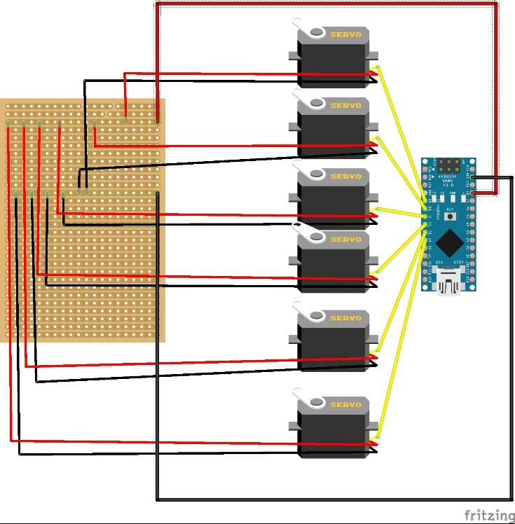

Fig 3.5.5: Connecting Servo to the Arduino Nano

3.5.6: CONNECTING THE MOTOR CONNECTED TO MOTOR DRIVER TO ESP 32 CAM
Motor drivers act as an interface between the motors and Esp 32 Cam, which send the instructions received from the Esp 32 to the motors. The controller can take up to 2 motors. Plug one motor into the terminal labelled out1 and out2 and plug the second motor into the terminal labelled out3 and out4. Then, the row of pins on the bottom right of the L298N controls the speed and direction of the motors. in1 and in2 control the direction of the motor connected to out1 and out2. in3 and in4 control the direction of the motor connected to out3 and out4. The L298N can be power with 12v by plugging your power source into the pin on the L298N labelled "12v". The pin labelled "5v" is a 5v output that you can use to power your Arduino. Now write the code. Setting in1 to high and in2 to low will cause the left motor to turn a direction. Setting in1 to low and in2 to high will cause the left motor to spin in the other direction, and the same applies to in3 and in4.

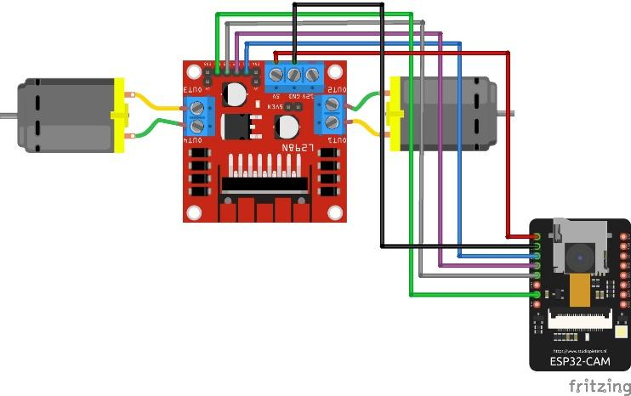

Fig 3.5.6: Pictorial Circuit Diagram of Connecting the Motor connected to Motor Driver to Esp 32 Cam

3.5.7: PROGRAM CODE
Below is the code used to make this system work:
Program Code for ESP 32 Cam:
#include <BluetoothSerial.h>

#if !defined(CONFIG_BT_ENABLED) || !defined(CONFIG_BLUEDROID_ENABLED)
#error Bluetooth is not enabled! Please run `make menuconfig` to and enable it
#endif

BluetoothSerial SerialBT;

String readString;
#define in1 14 //Connect in1 to pin 14
#define in2 15 //Connect in2 to pin 15
#define in3 13 //Connect in3 to pin 13
#define in4 12 //Connect in4 to pin 12
#define in5 4 //Connect in5 to pin 4 LED

void setup()
{
Serial.begin(115200);

// Bluetooth device name
SerialBT.begin("ZetaBot");
Serial.println("The device started, now you can pair it with bluetooth!");
pinMode(in1, OUTPUT); //Set in1 as an output
pinMode(in2, OUTPUT); //Set in2 as an output
pinMode(in3, OUTPUT); //Set in3 as an output
pinMode(in4, OUTPUT); //Set in4 as an output
pinMode(in5, OUTPUT); //Set pin 4 as an output
digitalWrite(in1, LOW); //Switch in1 off
digitalWrite(in2, LOW); //Swtich in2 off
digitalWrite(in3, LOW); //Switch in3 off
digitalWrite(in4, LOW); //Swtich in4 off
digitalWrite(in5, LOW); //Swtich Pin 4 off
}
void loop()
{
while (SerialBT.available()) //Check if there are available bytes to read
{
delay(10); //Delay to make it stable
char c = SerialBT.read(); //Conduct a serial read
if (c == '#') {
break; //Stop the loop once # is detected after a word
}
readString += c; //Means readString = readString + c
}
if (readString.length() > 0)
{
SerialBT.println(readString);
if (readString == "4") {
digitalWrite(in1, 1); // RF 14
digitalWrite(in2, 0); // RB 15
digitalWrite(in3, 0); // LF 13
digitalWrite(in4, 1); // LB 12
Serial.write(53);
delay(10);
}
else if (readString == "6") {
digitalWrite(in1, 0);
digitalWrite(in2, 1);
digitalWrite(in3, 1);
digitalWrite(in4, 0);
Serial.write(54);
delay(10);

}
else if (readString == "8") {
digitalWrite(in1, 1);
digitalWrite(in2, 0);
digitalWrite(in3, 1);
digitalWrite(in4, 0);
Serial.write(51);
delay(10);
}
else if (readString == "2") {
digitalWrite(in1, 0);
digitalWrite(in2, 1);
digitalWrite(in3, 0);
digitalWrite(in4, 1);
Serial.write(52);
delay(10);
}
else if (readString == "5") {
digitalWrite(in1, 0);
digitalWrite(in2, 0);
digitalWrite(in3, 0);
digitalWrite(in4, 0);
Serial.write(55);
delay(10);
}
// Tank Light
else if (readString == "9") {
digitalWrite(in5, HIGH);
delay(10);
}
else if (readString == "3") {
digitalWrite(in5, LOW);
delay(10);
}

// Arm
// Servo 1 Roll Right
else if (readString == "17") {
Serial.write(31);
delay(10);
}
// Servo 2 Roll Left
else if (readString == "16") {
Serial.write(32);
delay(10);
}
// Servo 2 Pitch Right
else if (readString == "19") {
Serial.write(33);
delay(10);
}
// Servo2 Pitch Left
else if (readString == "18") {
Serial.write(34);
delay(10);
}
// Servo 3 Grip Right
else if (readString == "21") {
Serial.write(35);
delay(10);
}
// Servo3 Grip Left
else if (readString == "20") {
Serial.write(36);
delay(10);
}
// Servo 4 Elbow Right
else if (readString == "23") {
Serial.write(37);
delay(10);
}
// Servo 4 Elbow Left
else if (readString == "22") {
Serial.write(38);
delay(10);
}
// Servo 5 Shoulder Right
else if (readString == "25") {
Serial.write(39);
delay(10);
}
// Servo 5 Shoulder Left
else if (readString == "24") {
Serial.write(40);
delay(10);
}
// Servo 6 Waist Right
else if (readString == "27") {
Serial.write(41);
delay(10);
}
// Servo 6 Waist Left
else if (readString == "26") {
Serial.write(42);
delay(10);
}
}
readString = "";
}

Program Code for ESP 32 Cam Live Stream:
Go to File – Examples - ESP 32 – Camera – CameraWebServer
Select Camera Model as CAMERA_MODEL_AI_THINKER
Change SSID and SSID Password
Note the Ip address on Serial Monitor on serial 115200

Program Code for Arduino Nano:
#include "LiquidCrystal_I2C.h"
#include <SPI.h> // to read from serial pin
LiquidCrystal_I2C lcd(0x27, 16, 2);
#include <Servo.h>
#include <SoftwareSerial.h>

String message0 = String("HELLO, I'M ZETABOT");
String message1 = String("Oke Iyanuoluwa Enoch");
String message2 = String("Mat No:- 1701326/17BD005101");
String message4 = String("Connecting ...");
String message5 = String("Bluetooth and Wifi Connected ");

int length0;
int length1;
int length2;
int length4;
int length5;

Servo servo01;
Servo servo02;
Servo servo03;
Servo servo04;
Servo servo05;
Servo servo06;

int servo1Pos, servo2Pos, servo3Pos, servo4Pos, servo5Pos, servo6Pos; // current position
int servo1PPos, servo2PPos, servo3PPos, servo4PPos, servo5PPos, servo6PPos; // previous position
int servo01SP[50], servo02SP[50], servo03SP[50], servo04SP[50], servo05SP[50], servo06SP[50]; // for storing positions/steps
int speedDelay = 20;
int index = 0;
String dataIn = "";

void setup()
{
Serial.begin(115200);

// Lcd
lcd.init();
lcd.backlight();
length0 = message0.length();
length1 = message1.length();
length2 = message2.length();
length4 = message4.length();
length5 = message5.length();

// Introduction Message
for (int i = 0; i < length0; i++)
{
ClearRow(0);
lcd.print(message0.substring(i, i + 15));
delay(500);
}

for (int i = 0; i < length1; i++)
{
ClearRow(0);
lcd.print(message1.substring(i, i + 15));
delay(500);
}
for (int i = 0; i < length2; i++)
{
ClearRow(1);
lcd.print(message2.substring(i, i + 15));
delay(500);
}

servo01.attach(5);
servo02.attach(6);
servo03.attach(7);
servo04.attach(4);
servo05.attach(3);
servo06.attach(2);
delay(20);

// Send 90 degrees to servos before assembling servos

// Robot arm initial position
servo1PPos = 65;
servo01.write(servo1PPos);
delay(300);

servo2PPos = 90; //50
servo02.write(servo2PPos);
delay(300);

servo3PPos = 80;
servo03.write(servo3PPos);
delay(300);

servo4PPos = 20;
servo04.write(servo4PPos);
delay(300);

servo5PPos = 120;
servo05.write(servo5PPos);
delay(300);

servo6PPos = 50;
servo06.write(servo6PPos);
delay(300);

}

void loop()
{
// Tank Messages
// Forward Message
if (Serial.available() > 0) {
if (Serial.read() == 51) {
lcd.clear();
lcd.setCursor(0, 0);
lcd.print("Moving Forward");
delay(100);
}
}

// Backward Message
if (Serial.available() > 0) {
if (Serial.read() == 52) {
lcd.clear();
lcd.setCursor(0, 0);
lcd.print("Moving Backward");
delay(100);
}
}

// Left Message
if (Serial.available() > 0) {
if (Serial.read() == 53) {
lcd.clear();
lcd.setCursor(0, 0);
lcd.print("Moving Left");
delay(100);
}
}

// Right Message
if (Serial.available() > 0) {
if (Serial.read() == 54) {
lcd.clear();
lcd.setCursor(0, 0);
lcd.print("Moving Right");
delay(100);
}
}

// Stop Message
if (Serial.available() > 0) {
if (Serial.read() == 55) {
lcd.clear();
lcd.setCursor(0, 0);
lcd.print("Moving Stopped");
delay(100);
}
}

// Arm Code
// Roll
if (Serial.available() > 0) {
if (Serial.read() == 31) {
servo1PPos = servo1PPos + 20;
servo01.write(servo1PPos);
delay(10);
lcd.clear();
lcd.setCursor(0, 0);
lcd.print("Roll Right");
}
}

if (Serial.available() > 0) {
if (Serial.read() == 32) {
servo1PPos = servo1PPos - 20;
servo01.write(servo1PPos);
delay(10);
lcd.clear();
lcd.setCursor(0, 0);
lcd.print("Roll Left");
}
}

// Pitch
if (Serial.available() > 0) {
if (Serial.read() == 33) {
servo2PPos = servo2PPos + 20;
servo02.write(servo2PPos);
delay(10);
lcd.clear();
lcd.setCursor(0, 0);
lcd.print("Pitch Right");
}
}

if (Serial.available() > 0) {
if (Serial.read() == 34) {
servo2PPos = servo2PPos - 20;
servo02.write(servo2PPos);
delay(10);
lcd.clear();
lcd.setCursor(0, 0);
lcd.print("Pitch Left");

}
}

// Grip
if (Serial.available() > 0) {
if (Serial.read() == 35) {
servo3PPos = servo3PPos + 20;
servo03.write(servo3PPos);
delay(10);
lcd.clear();
lcd.setCursor(0, 0);
lcd.print("Grip Right");
}
}

if (Serial.available() > 0) {
if (Serial.read() == 36) {
servo3PPos = servo3PPos - 20;
servo03.write(servo3PPos);
delay(10);
lcd.clear();
lcd.setCursor(0, 0);
lcd.print("Grip Left");
}
}

// Elbow
if (Serial.available() > 0) {
if (Serial.read() == 37) {
servo4PPos = servo4PPos + 20;
servo04.write(servo4PPos);
delay(10);
lcd.clear();
lcd.setCursor(0, 0);
lcd.print("Elbow Right");
}
}

if (Serial.available() > 0) {
if (Serial.read() == 38) {
servo4PPos = servo4PPos - 20;
servo04.write(servo4PPos);
delay(10);
lcd.clear();
lcd.setCursor(0, 0);
lcd.print("Elbow Left");
}
}

// Shoulder
if (Serial.available() > 0) {
if (Serial.read() == 39) {
servo5PPos = servo5PPos + 20;
servo05.write(servo5PPos);
delay(10);
lcd.clear();
lcd.setCursor(0, 0);
lcd.print("Shoulder Right");
}
}

if (Serial.available() > 0) {
if (Serial.read() == 40) {
servo5PPos = servo5PPos - 20;
servo05.write(servo5PPos);
delay(10);
lcd.clear();
lcd.setCursor(0, 0);
lcd.print("Shoulder Left");
}
}

// Waist
if (Serial.available() > 0) {
if (Serial.read() == 41) {
servo6PPos = servo6PPos + 20;
servo06.write(servo6PPos);
delay(10);
lcd.clear();
lcd.setCursor(0, 0);
lcd.print("Waist Right");
}
}

if (Serial.available() > 0) {
if (Serial.read() == 42) {
servo6PPos = servo6PPos - 20;
servo06.write(servo6PPos);
delay(10);
lcd.clear();
lcd.setCursor(0, 0);
lcd.print("Waist Left");
}
}

}

void ClearRow(int rowNum)
{ lcd.setCursor(0, rowNum);
lcd.print(" ");
lcd.setCursor(0, rowNum);
}

Kodular Code for Project Mobile Application:
Robotic Tank Controller Code:
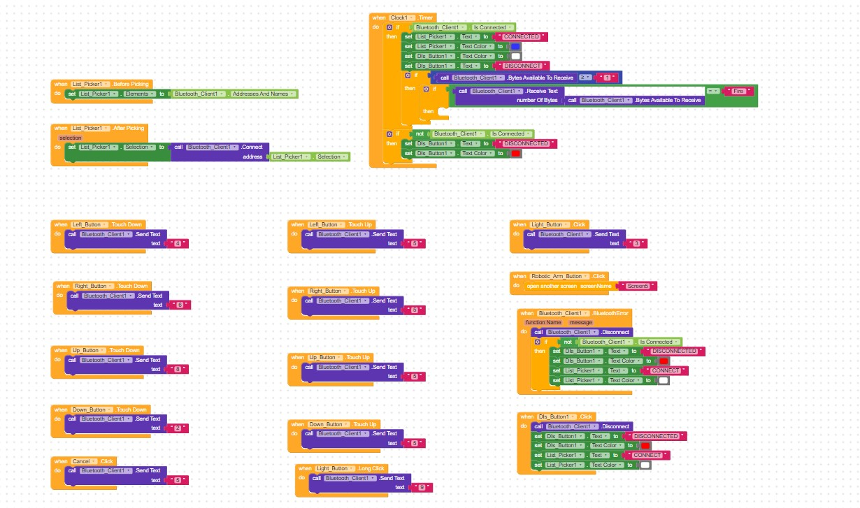

Robotic Arm Controller Code:
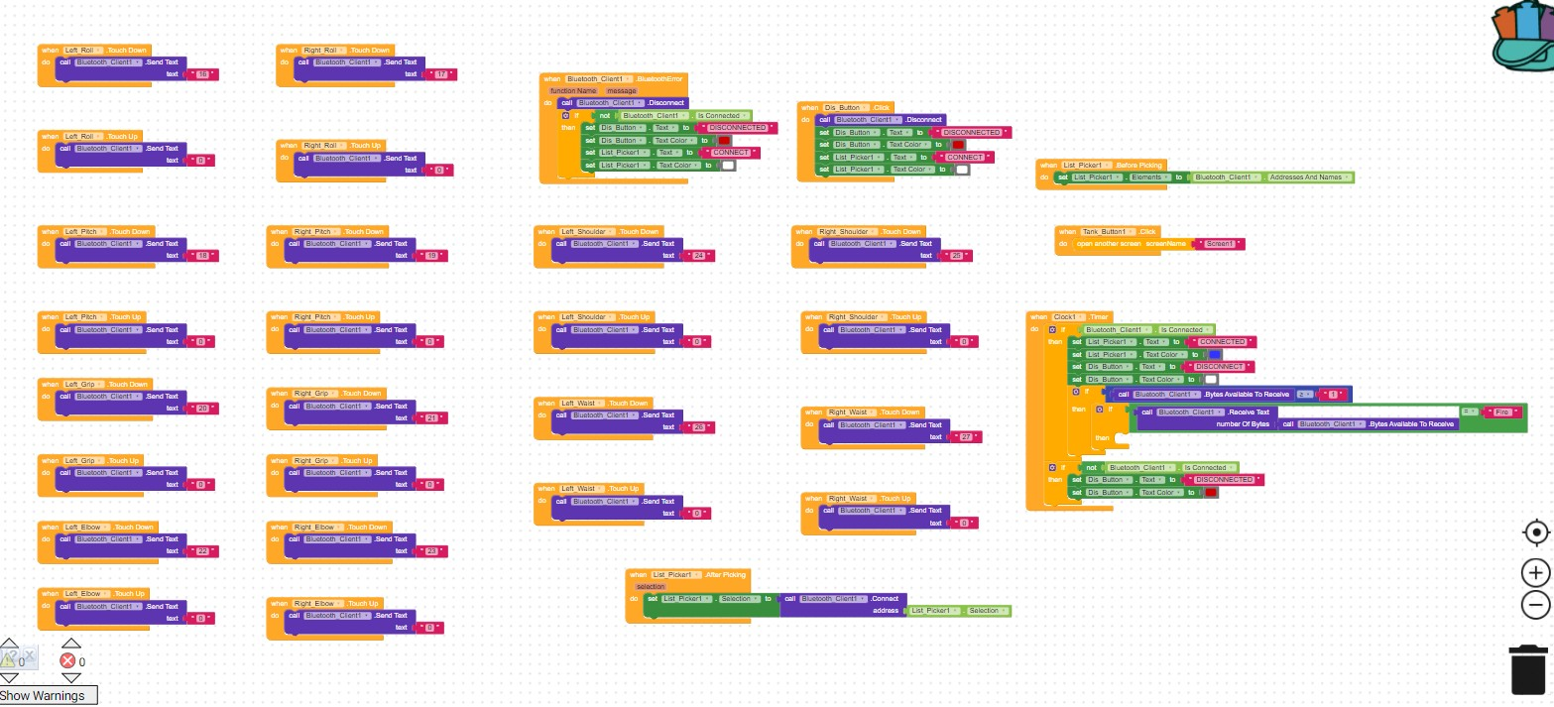

CHAPTER 4
RESULTS AND DISCUSSIONS
4.1 RESULTS AND DISCUSSION
The constructed project was made according to the Pictorial Circuit Diagram and Circuit Diagram in Fig 3.3.2 and Fig 3.4 respectively, which produced expected results.

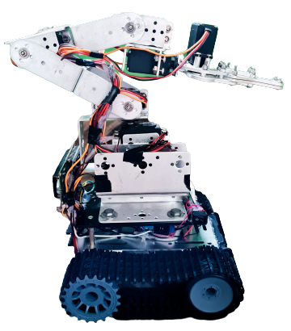

Fig 4.1 Final Constructed Project Result
The “LMU WIFI” was used to connect Esp 32 Cam to the internet and the laptop was connected to the WIFI providing a constant WIFI SSID and WIFI Password for a live stream footage. The app is connected to the project through a Bluetooth. Every output from the project is monitored through the LCD screen. The appliances are connected according to the circuit diagrams. The Tank is power by 3 x 3.7v lithium battery providing a total of 11v, and the Arm is power by 2 x 3.7v lithium battery providing a total of 7.4v, voltage connected to the project.
This project is operating as stated in this report. Instructions are sent and received by the Esp 32 Cam through inbuilt Bluetooth feature and share received instruction across the other components in the project. The live video footage from the Esp 32 Cam is monitor from the laptop screen using a ip address. The Ip address is the internet protocol address of the Esp 32 Cam which is found on the serial monitor of the Arduino Ide as Esp 32 Cam is connected to a network.
The App is sectioned in two ways, the first part of the app controls the Tank while the second part of the app control the Arm. The directions on the app is used to control the tank wheel in different directions. The Arm app section is used to control each joint part of the Arm.

CHAPTER 5
CONCLUSION AND RECOMMENDATION
5.1 RECOMMENDATION
The project is not basically for Robotic Greenhouse Farming, but also in any area of field research purpose. Network (Wifi) is something that is very important in this project makeup. It is recommended that when setting this project, a strong network or Wifi signal is to be used or a separate network connection should be set up for the project alone, a strong network connection is require for the live stream footage from the Esp 32 Cam.

5.2 CONCLUSION
I successfully designed and implemented the proposed low-cost robot, as explained in this project report. The mobile app is user friendly and self-explanatory, once the mobile is connected to the robot is shows connected and the robot displaying a welcome message indicating the robot is still booting. With this project being designed and implemented, a user-friendly, scalable, open-source and low-cost agrotechnology is believed to have been achieved.
Although, the project was initially planned to be operated over the Internet instead of Bluetooth Connection, this was due to lack of strong internet and availability of materials need for the seamless transmission.

REFERENCES
- What Is Robotics? (2009, November 9). Retrieved from https://www.nasa.gov/audience/forstudents/k-4/stories/nasa-knows/what_is_robotics_k4.html
- Robots in The Lab. (2012, May 10). Automate. Retrieved from https://www.automate.org/industry-insights/robots-in-the-lab
- Robotics in Manufacturing. (n.d.). Acieta. Retrieved from https://www.acieta.com/why-robotic-automation/robotics-manufacturing/
- Everything You Need to Know About Robotic Arms. (n.d.). Retrieved from https://ie.rs-online.com/web/generalDisplay.html?id=ideas-and-advice/robotic-arms-guide
- 6 Common Applications for Robots in Automotive Manufacturing. (n.d.). Genesis Systems. Retrieved from https://www.genesis-systems.com/blog/robots-automotive-manufacturing-top-6-applications
- A Problem Statement of Robotics Technologies Information Technology Essay. (n.d.). Retrieved from https://www.ukessays.com/essays/information-technology/a-problem-statement-of-robotics-technologies-information-technology-essay.php?vref=1
- Robotics: A Brief History from https://cs.stanford.edu/people/eroberts/courses/soco/projects/1998-99/robotics/history.html
- Arduino Development Boards. (n.d.). Retrieved from https://eu.mouser.com/applications/open-source-arduino/
- Getting Started with ESP32 CAM Board & Video Streaming Over WiFi. (n.d.). How To Electronics from https://how2electronics.com/getting-started-with-esp32-cam-board-video-streaming-over-wifi/
- ESP32-CAM - Getting Started & Solving Common Problems. (n.d.). DroneBot Workshop. Retrieved from https://dronebotworkshop.com/esp32-cam-intro/
- L298N Motor Driver Board - Geeetech Wiki. (n.d.). Retrieved from https://www.geeetech.com/wiki/index.php/L298N_Motor_Driver_Board
- Motor Driver Module-L298N - Wiki. (n.d.). Retrieved from http://wiki.sunfounder.cc/index.php?title=Motor_Driver_Module-L298N
- DC Motor Direction Control Using Arduino Uno with L298 Driver. (n.d.). Retrieved from https://www.ukessays.com/essays/engineering/dc-motor-direction-control-using-arduino-uno-with-l298-driver.php
- Servo Motors - Arduino - Wiki.nus. (n.d.). Retrieved from https://wiki.nus.edu.sg/display/Arduino/Servo+Motors#ServoMotors-SG90MicroServo
- For, E. (2021, July 17). 16x2 LCD Pinout Diagram | Interfacing 16x2 LCD With Arduino. Electronics for You. Retrieved from https://www.electronicsforu.com/technology-trends/learn-electronics/16x2-lcd-pinout-diagram
- Kodular (2021, May 30). Everybody Wiki Bios & Wiki. Retrieved from https://en.everybodywiki.com/Kodular

